**SHRAMIK SEVA NGO**

Shramik Seva NGO is a non-profit NGO created as a part of sem-2 web programming mini-project. It is a free food delivery service for the poor migrants during the times of covid-19, who don’t have adequate food to eat. As a result, they or someone else on their behalf may contact us through our **contact page**. As well as this, citizens can also donate with us using their debit cards/credit cards.

We have provided suitable and sensible information regarding the pandemic too. We have provided a **video** for kids to understand the need of safety precautions during the time of the pandemic. As well as this the video provides essential details for the parents on what things to do with their children during the time of this pandemic.

In our **about us** **page**, we have provided a brief description of our work over the years. We have also provided the details of what different facilities, we are providing during this time of pandemic.

In our **work page**, we have provided details of the food we serve and the methodology opted by us for home delivery. (Details will be explained)

In **our reach page**, we have provided contact numbers of our on-ground teams in respective areas of Delhi and other states. It also provides details of the address of the offices, just in-case someone wants to meet in-person.

Registration page

**-Alok Prasad, U19CS119**

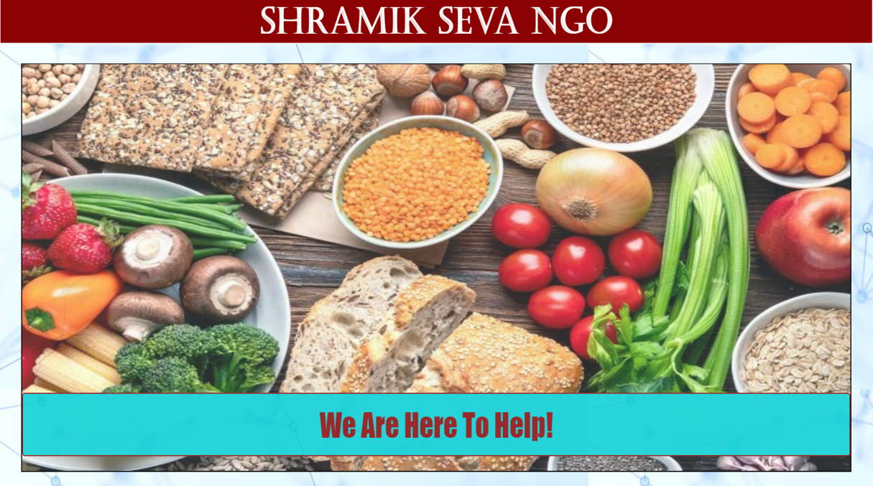**Registration page:** It is the first page the user gets access to. It contains a header division containing the name i.e. SHRAMIK SEVA NGO, a slideshow division containing a slideshow, quotes (text), and dots (design), a form division containing a registration form for the user to sign-up and lastly a footer division for the links to our various social-media sites.

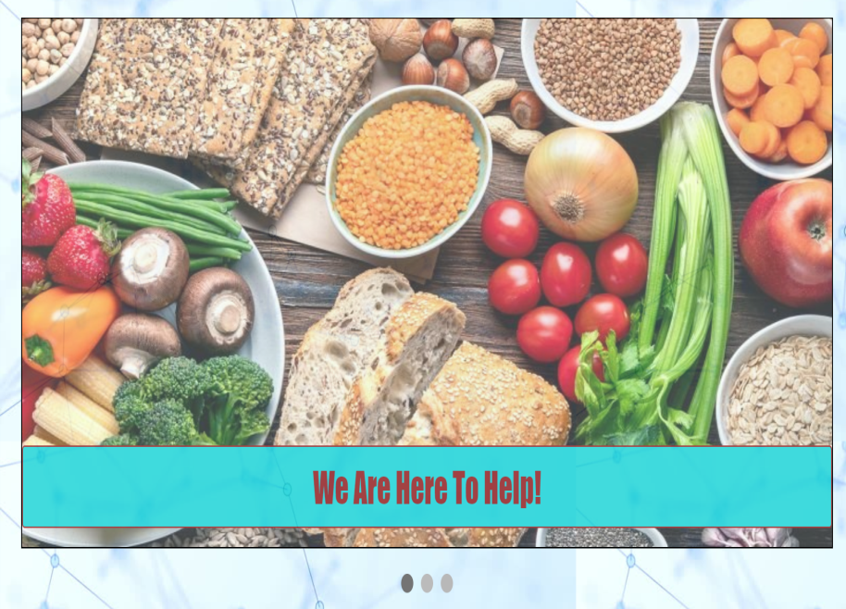**Slideshow:** The slideshow division contains 3 images, 3 quotes and 3 dots. Each one of them has been added (right). It is an automatic animation made using **webkit-keyframes.** The animation used is called fade i.e. the images go from 1 opacity to 0.4 opacity before changing into the next image. The duration of each slide is 4 seconds and the duration of the animation (fade) is 2 seconds.

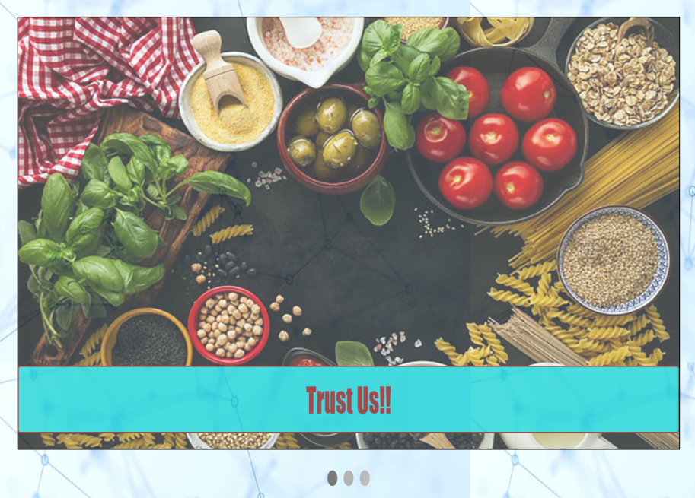The slideshow also uses javascript. In-line javascript code has been added in-order to show each of the slides alternatively. This has been done using loops like for and if.

**Texts** have been added using a separate division inside the division slideshow. In this various quotes have been added. The design of the quotes has been done using CSS, i.e.(background-color: cadet blue, color: dark red, font-family : sheriff).

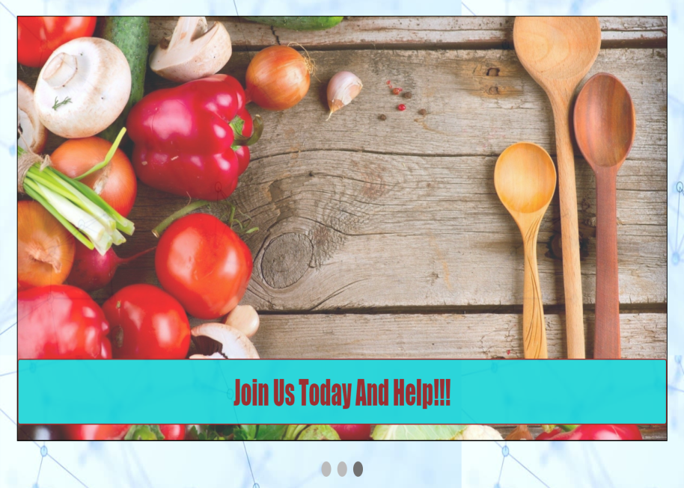**Dots** have been added using a separate division inside the slideshow division.

It uses the transition effect. As a result, after every 2 seconds, the color of one of the three dots will ease (fade) and the dot next to it will gain color.

**Registration form:** This is a validated registration page, i.e. various rules have been put in place as to how to fill the form. These conditions have been put using javascript. For example the code for the conditions for the username are :-

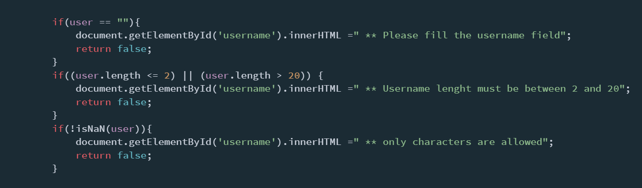

Similarly other conditions for password, email, number…etc has been put.

If any of the conditions are breached, a message for the same will be displayed. This message is red in color in order to represent error.

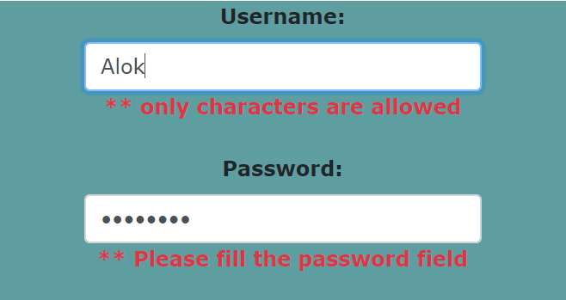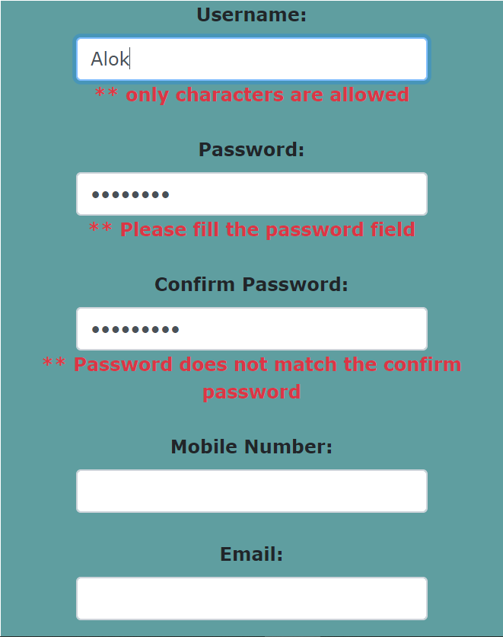

**Layout of the form:** Bootstrap has been used for the layout of the table as well as the layout of the “submit” and “submit without validation” buttons.

The submit button will only redirect (hyperlink) to the homepage if the details fill are correct. If the user wants to access the page without it, he can do so by using submit without validation button. However, submit without validation button will not allow the user to access the raise funds page.

**Footer division**: The footer division gives user the access to the terms &conditions page of our NGO as well as the links to our social-media pages i.e. on Facebook, YouTube, twitter etc.

On clicking any of the logos, the user will be re-directed to the respective pages.

The layout of the footer tag has been made using bootstrap links as well as internal CSS.

*Code for footer tag has been further explained in the homepage section.*

**Helpline division:** The helpline div is a fixed division. It contains a helpline number, which moves towards right (done using marquee tag). Its layout is done using CSS.



[validated registration page.html](validated%20registration%20page.html)

About us

-Alok Prasad, U19CS119

**About us:** The about us page contains firstly the top-navigation division. The top-navigation allows the user to navigate through all the web-pages created by us; secondly it contains division “first”. The division “First” contains information regarding the NGO. As well as this, it also contains an image; thirdly another division “second” is there. It contains text, image and a button i.e. DONATE NOW button. Lastly the page contains the same footer tag as that on the registration page.

**Top-Navigation bar:** The top-navigation division contains hyperlinks for the various pages. It has been styled using CSS. On-clicking any page re-directs the user to that page.



**Layout:** Its layout has been designed using CSS. It contains various features. For example the hover feature i.e.



**Division First:-**

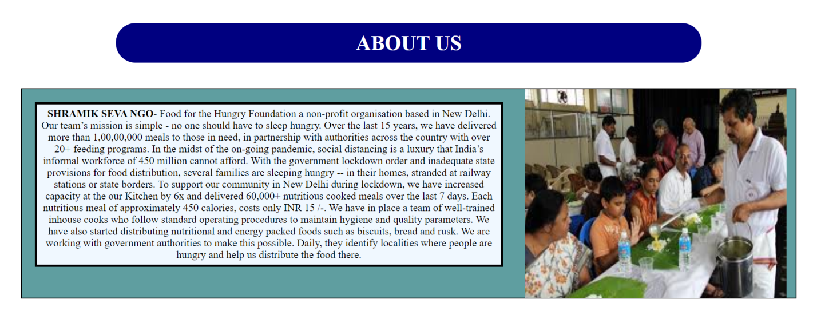

**Division second:-**

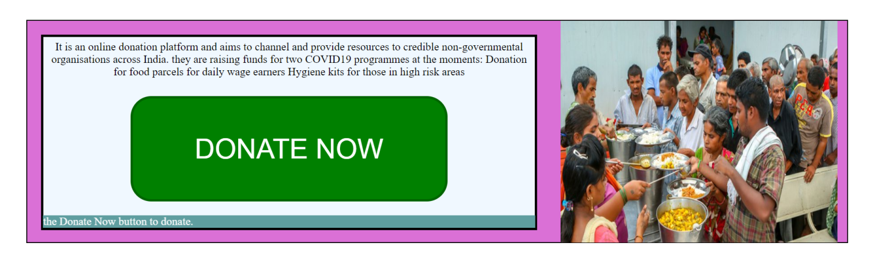

**Donate now button:** On clicking the “donate now” button, the user is re-redirected to the payment page. Over here, the user first has to fill this validated form and press submit button (made using bootstrap). He can also reload the page using the reset button.

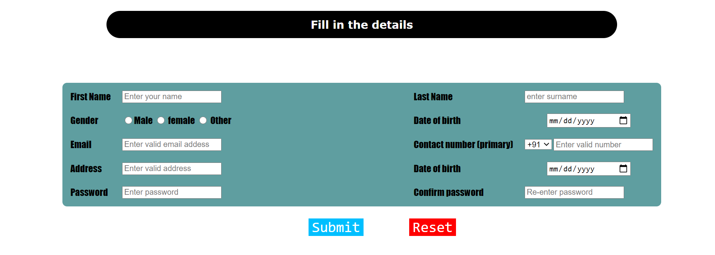

If the user fills the validated form correctly, he will be able to access the payment page i.e.

*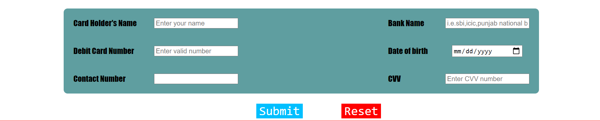More details about this page will be explained in the raise fund section.*

**Helpline division:** The helpline div is a fixed division. It contains a helpline number, which moves towards right (done using marquee tag). Its layout is done using CSS.



[**about us.html**](about%20us.html)

**//Rest of the documentation has been lost. Retrieval of the data is in progress.**